**Trader Oracle Testing**

1. Sign In

Action: Sign in Page

Steps: Go to apex oracle.

Expected Results:Traders are directed to login page

Pass/Fail:Pass

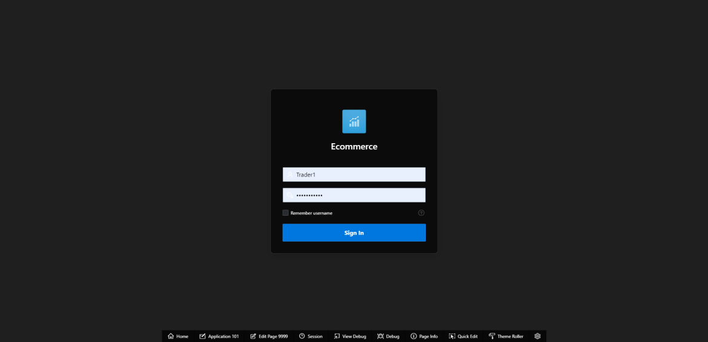

Action:correct password and email

Steps: Fill the correct information in an appropriate box.

Expected Results:Goes into the dashboard

Pass/Fail:Pass

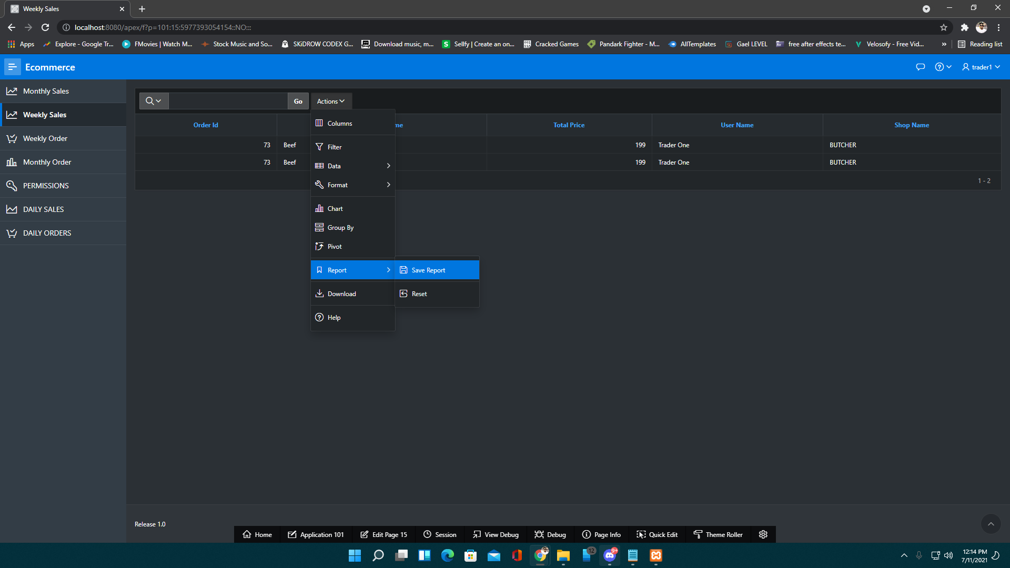

Action: incorrect password and email

Steps: Fill the incorrect login credentials.

Expected Results:An error message is displayed

Pass/Fail:Pass

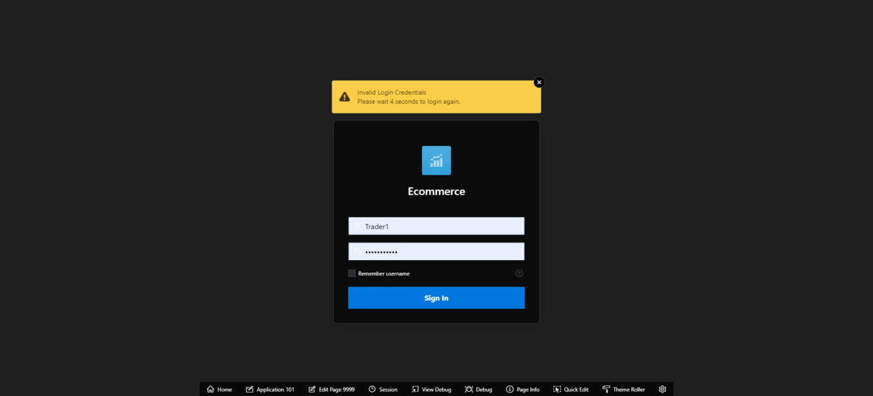

1. Reports

Action: View monthly sales

Steps: Click on Monthly sales.It shows the details of the products that are sold within a month.

Expected Results :Display the Trader's monthly sales

Pass/Fail: Pass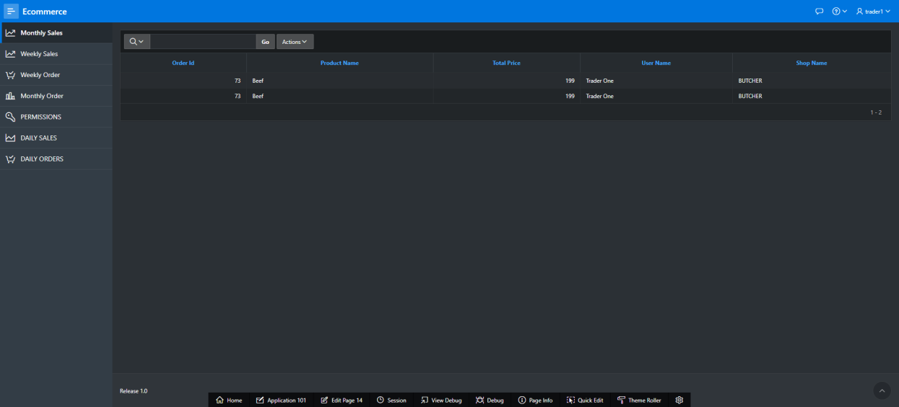

Action: View monthly order

Steps:Click on Monthly order.It shows the details of the products that are order within a month

Expected Results:display the Trader's monthly order

Pass/Fail:Pass

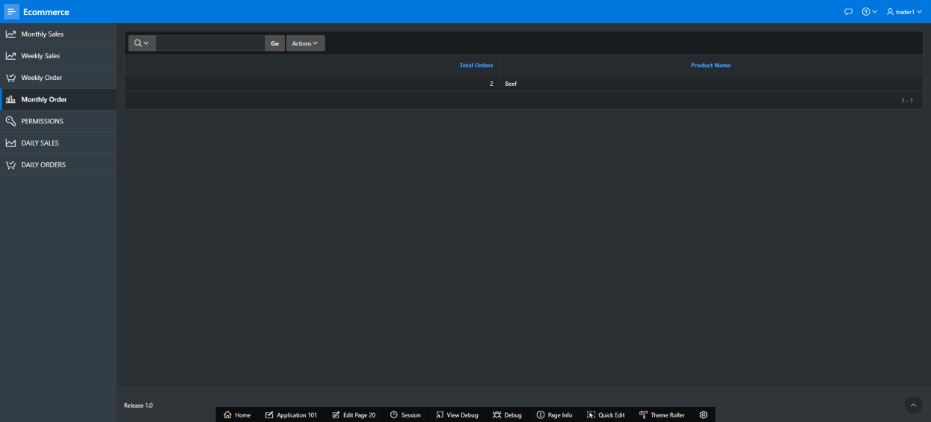

Action:view weekly sales

Steps:Click on weekly sales.It shows the details of the products that are sold within a week

Expected Results:display the Trader's weekly sales

Pass/Fail: Pass

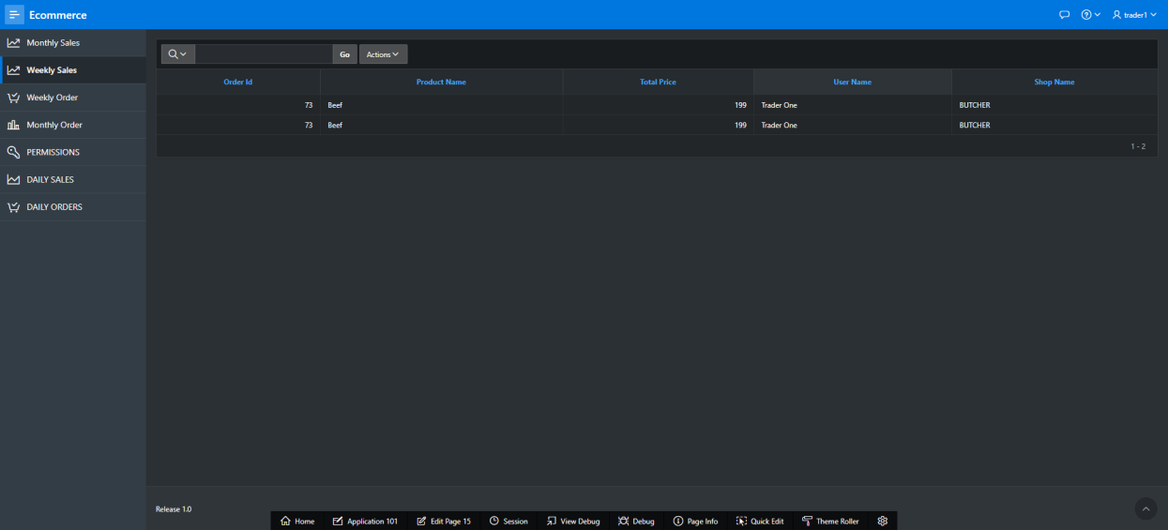

Action:view weekly order

Steps:Click on Weekly order..It shows the details of the products that are order within a week.

Expected Results:display the Trader's weekly order

Pass/Fail: Pass

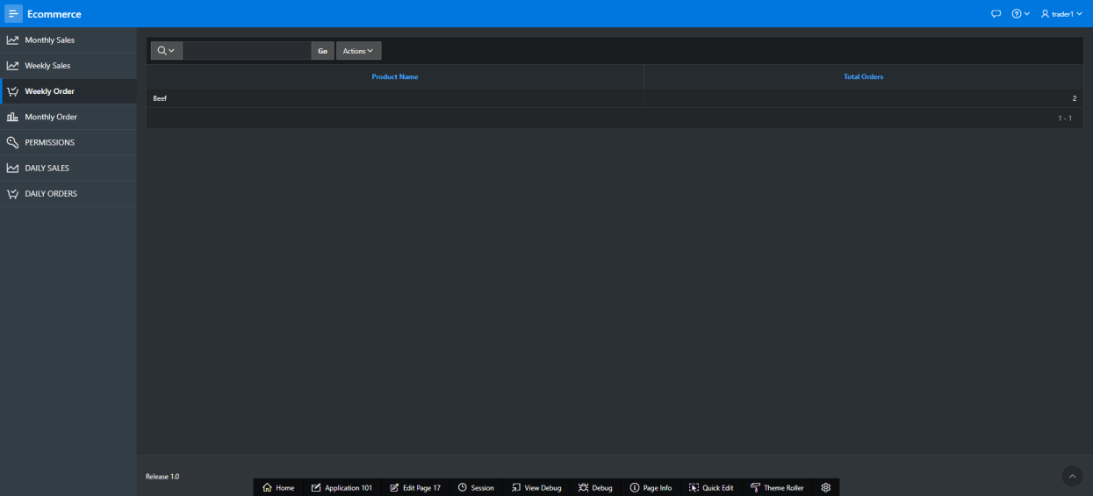

Action: View daily sales

Steps:Click on product of which you want to see or view rating and review.

Expected Results:display the Trader's daily sales

Pass/Fail:Pass

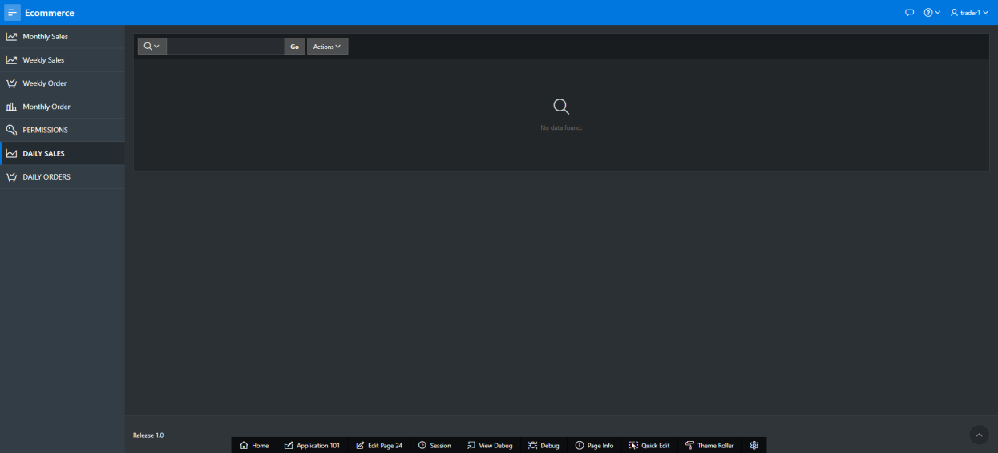

Action: View daily order

Steps:Click on daily order.It shows the details of the products that are order within 24 hours.

Expected Results: Display the Trader's daily order

Pass/Fail: Pass

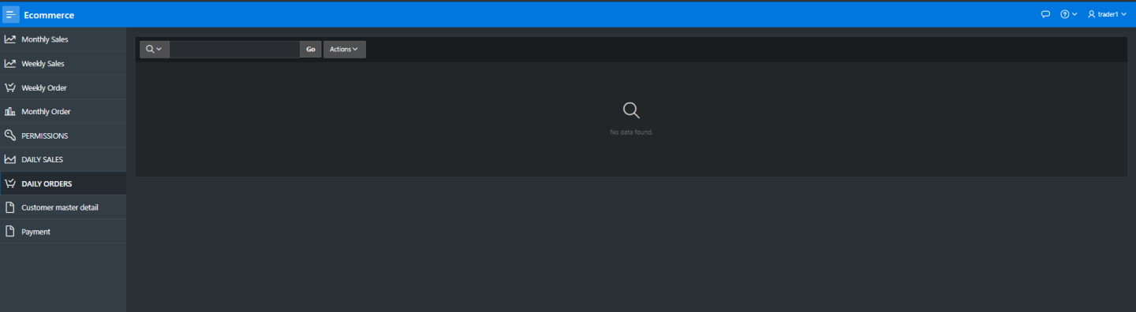

1. Logout

Action: Sign out page

Steps: Click on logout button.

Expected Results:You can log out from the dashboard.

Pass/Fail:Pass

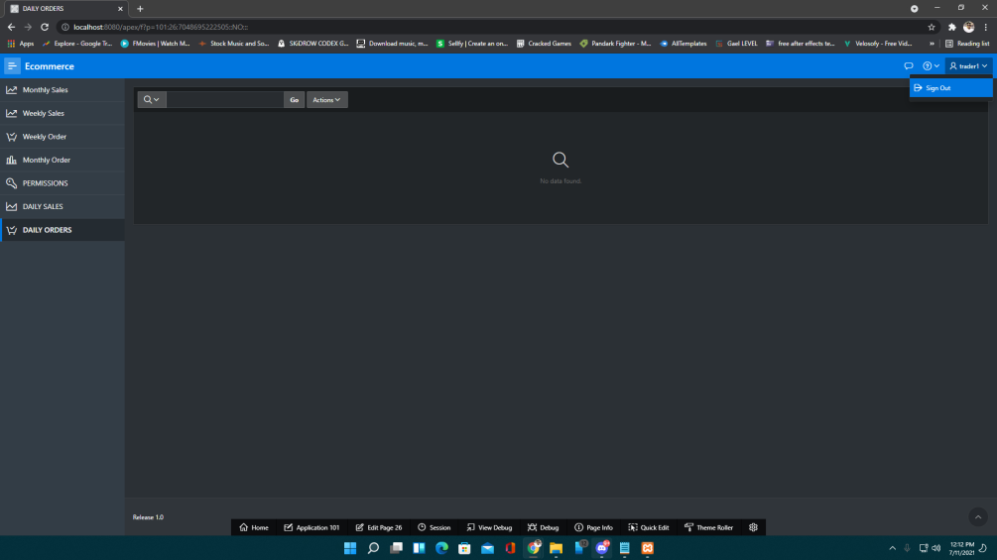

Action:

Steps:

Expected Results:

Pass/Fail: